**Google Tag Manager Snippet - Staging**

Ensure that the Google Tag Manager (GTM) snippet is in the head on all pages and has the correct ‘GTM-NWLC5L’ ID value

<script>(function (w, d, s, l, i) {w[l] = w[l] || []; w[l].push({‘gtm.start’:

new Date().getTime(), event: ‘gtm.js’}); var f = d.getElementsByTagName(s)[0],

j = d.createElement(s), dl = l != ‘dataLayer’ ? ‘&l=‘ + l : ‘‘; j.async = true; j.src =

‘//www.googletagmanager.com/gtm.js?id=‘ + i + dl; f.parentNode.insertBefore(j, f);

})(window, document, ‘script’, ‘dataLayer’, ‘GTM-NWLC5L’);</script>

<noscript><iframe src=‘//www.googletagmanager.com/ns.html?id= GTM-NWLC5L’

height=‘0’ width=‘0’ style=‘display:none;visibility:hidden’></iframe></noscript>

**Google Tag Manager Snippet - Live**

Ensure that the Google Tag Manager (GTM) snippet is in the head on all pages and has the correct ‘GTM-KL82H2’ ID value

<script>(function (w, d, s, l, i) {w[l] = w[l] || []; w[l].push({‘gtm.start’:

new Date().getTime(), event: ‘gtm.js’}); var f = d.getElementsByTagName(s)[0],

j = d.createElement(s), dl = l != ‘dataLayer’ ? ‘&l=‘ + l : ‘‘; j.async = true; j.src =

‘//www.googletagmanager.com/gtm.js?id=‘ + i + dl; f.parentNode.insertBefore(j, f);

})(window, document, ‘script’, ‘dataLayer’, ‘GTM-NDKVQS’);</script>

<noscript><iframe src=‘//www.googletagmanager.com/ns.html?id= GTM-NDKVQS’

height=‘0’ width=‘0’ style=‘display:none;visibility:hidden’></iframe></noscript>

**Datalayer**

Deploying GTM creates a Javascript object which can be used to store data for analytics purposes and persist for the length of the users’ session.

The syntax for pushing data to the dataLayer object is

dataLayer.push({

'event': 'eventName',

'key': 'value'

});

**On click of log in**

ga('send', 'event', 'login', '{url path}');

Where {url path} is the path of the current page.

i.e If the current page was http://devcasino.int.sportingindex.com/mini-games

ga('send', 'event', 'login', '/mini-games ');

Except for the homepage where this should be '/casino-homepage'

**Once login has been approved**

Push the following values to the data layer

dataLayer.push{

'userID': '<%: Model.CustomerAccountNumber %>',

'membershipStar': '<%: Model.AccountOpenedDate.HasValue ? Model.AccountOpenedDate.Value.ToString("yyyy/MM/dd") : string.Empty %>',

'membershipType': '<%: Model.AccountCategory %>',

'event': 'loggedIn'

}

**As pass whether user is authorized for Casino or not as per:**

[**https://sportingsolutions.atlassian.net/browse/CASINO-487**](https://sportingsolutions.atlassian.net/browse/CASINO-487)

**On click of join now**

ga('send', 'event', 'join now', '{url path}');

Where {url path} is the path of the current page.

i.e If the current page was http://devcasino.int.sportingindex.com/mini-games

ga('send', 'event', 'join now', '/mini-games ');

Except for the homepage where this should be '/casino-homepage'

**On click of contact us or chat**

ga('send', 'event', '{link name}', '{url path}');

Where {link name} is either 'contact us' or 'chat' and {url path} is the path of the current page.

i.e If the current page was http://devcasino.int.sportingindex.com/mini-games

ga('send', 'event', 'contact us', '/mini-games ');

Except for the homepage where this should be '/casino-homepage'

**Casino Nav**

**Slider**

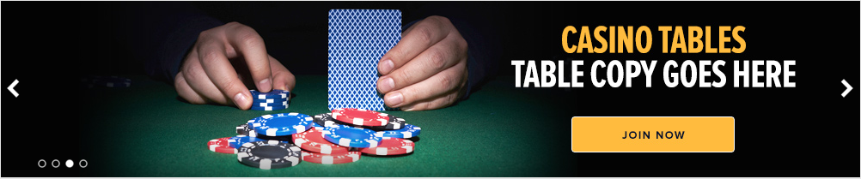

**On click of slider body**

ga('send', 'event', 'casino slider', 'body', '{link value}');

Where {link value} is url the body links to

**On click of slider button**

ga('send', 'event', 'casino slider', 'button', '{button value}');

Where {button value} is text displayed on the button in all lowercase

**Top Nav**

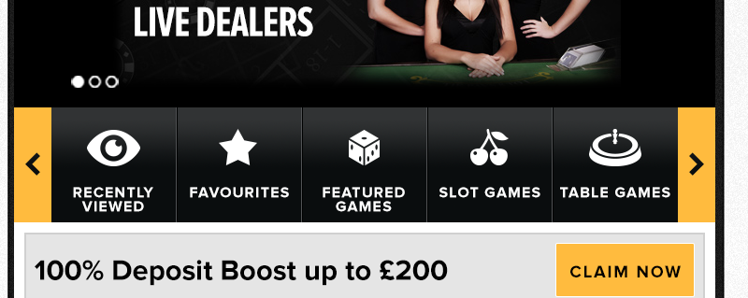

**On click of link**

ga('send', 'event', 'casino mobile top nav', 'link', '{link value}');

**Games Tiles Interactions**

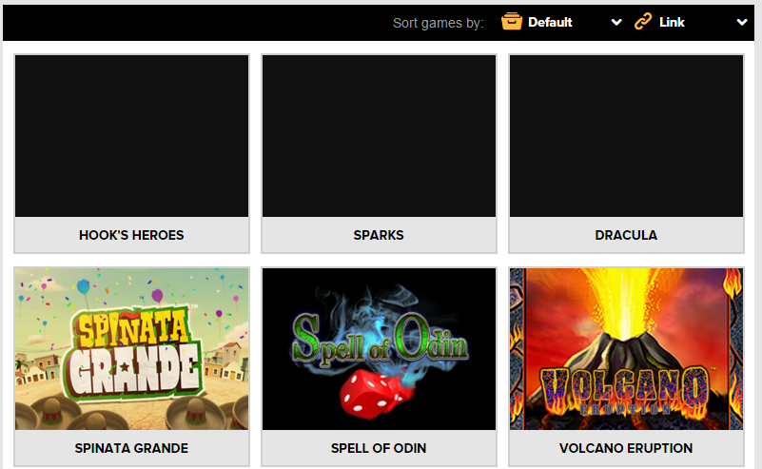

**On click of tiled game**

ga('send', 'event', '{game type} | {game name}', '{game launch mode}', '{game position}');

Where

'{game type}' is the type of game i.e ‘table games’, ‘video slots’ etc…

{game name}' is the name of the game

'{game launch mode}' is the launch mode i.e link or pop up or overlay

'{game position}' is the order number of the game as displayed i.e Hook’s Heroes would 1, Volcano Eruption 6

dataLayer.push({

'event': 'casinoGameClicked',

'gameType': '{game type}',

'gameName':'{game name}',

'gameLaunchMode':'{game launch mode}',

'gamePosition':'{game position}'

});